Kingswood Chase Lodge
2 Great Events for 2026!

WM Martin Thomas and Mrs Marilyn Thomas
invite you to join them and enjoy 2 great events!
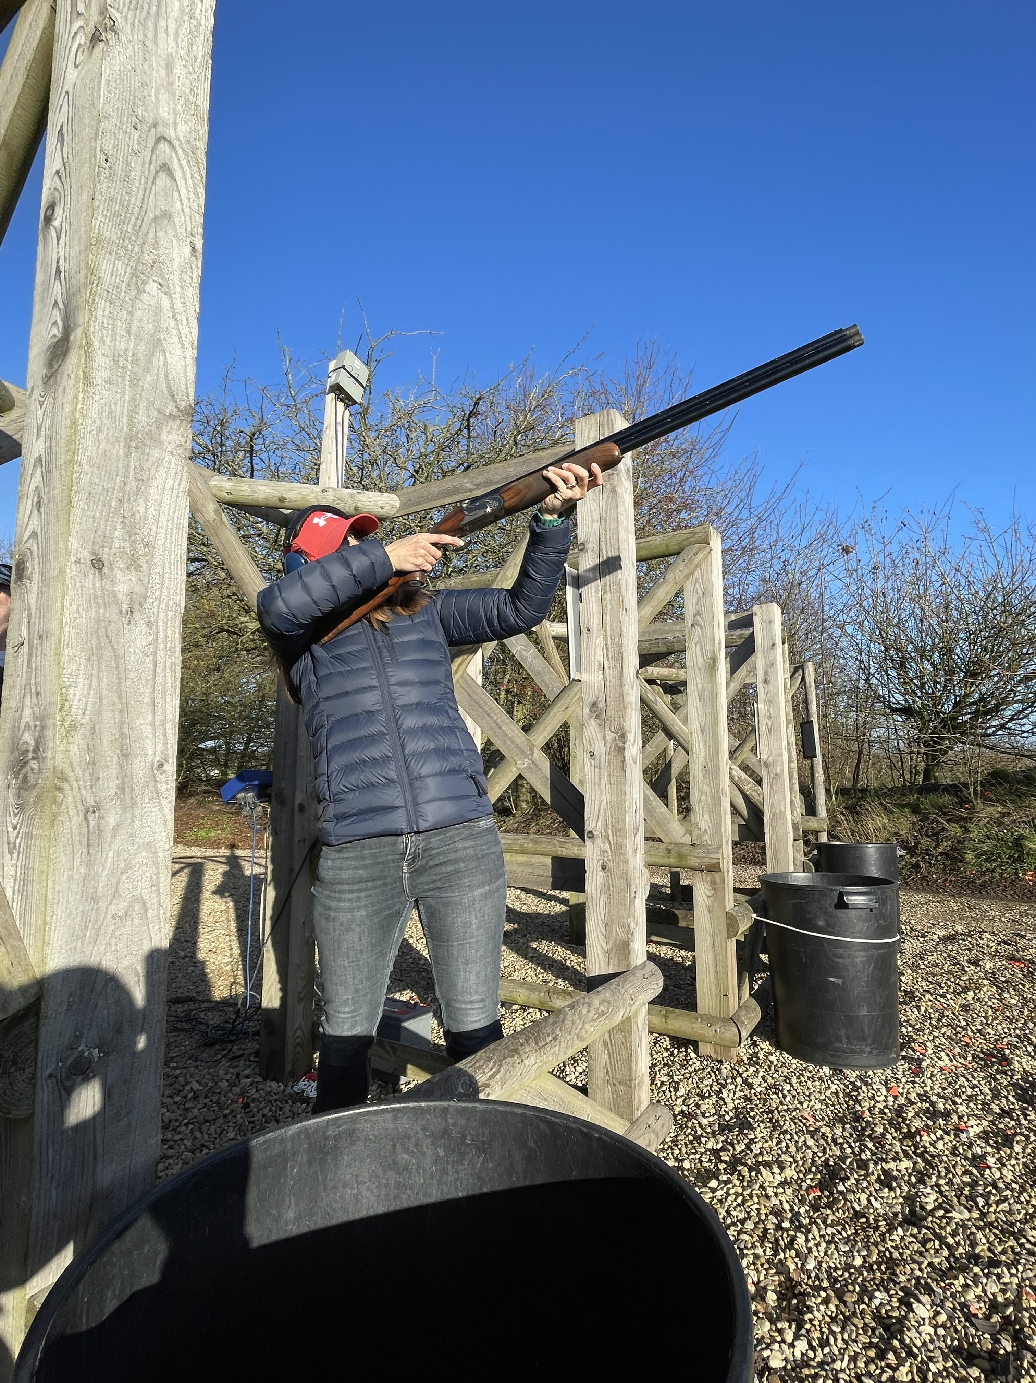
9 May (Saturday)
Clay Pigeon Shooting Experience – £45
Barbury Shooting School, near Swindon
[aimed at novices, 40 shots, gun hire, teas/coffee, pasty or sausages and chips for lunch]
Experienced gun licence holders will accompany novices in small groups of 5
Numbers are limited so get in early!

20 June (Saturday)
Midsummer Ball - £46 - Chipping Sodbury Town Hall
Welcome drink (prosecco, fruit juice)
3 course meal (£3 supplement applies to lamb shank option)
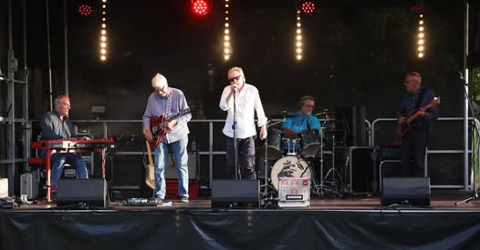
Tea or coffee to finish
Live band (Red Rooster)
Raffle – of course!
Dancing until midnight

Arrive 6.30 pm, start at 7.00 pm, carriages at 12 midnight

Dress code: Black Tie with Dinner Jacket, evening dress for ladies

Menu:
Starters
Roasted tomato and pepper soup with a bread roll (v), or
Pressed ham hock terrine with chutney and sourdough bread

Mains
Chicken supreme served with dauphinoise potatoes and seasonal vegetables, or
Lamb shank in a red wine jus served with dauphinoise potatoes and seasonal vegetables (a supplement charge of £3 per person applies), or
Vegan Wellington served with roast potatoes and seasonal vegetables (Ve)

Desserts
Chef’s NY cheesecake served with a fruit coulis and cream, or
Chef’s chocolate brownie served with vanilla ice cream, or
Vegan and gluten free options available upon request

Please contact the WM, Martin Thomas 0117 9374638 or email martinthomas_98@yahoo.com

Name | Menu choice | Paid
 | Start
 | Main
 | Dessert
 | Start
 | Main
 | Dessert
 | Start
 | Main
 | Dessert
 | Start
 | Main
 | Dessert
 | Start
 | Main
 | Dessert
 | Start
 | Main
 | Dessert

